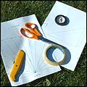 | You will need:  A pair of scissors  A compass  Some sellotape  A craft knife  A print-out of the two sundial templates
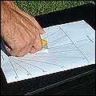 | Place the main sheet on a hard surface and using the craft knife, cut down the line that says 'cut here' (ask an adult to help you).
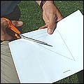 | Using the scissors, carefully cut out the template for the gnomon, the triangle shape.
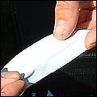 | Once you have done that, fold it along the line.
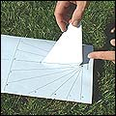 | Now place the gnomon inside the slit of the sundial template. You must make sure the right-angle is at the bottom of the sundial template (see picture).
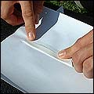 | Now using the sellotape, stick the bottom of the gnonom to the base of the sundial.
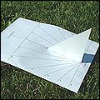 | The gnomon should stand up by itself, but you may need to secure it with some more sellotape at its base.
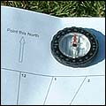 | Find north with the compass - you'll need to slowly turn in a circle until the pointer points north.
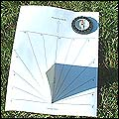 | Once you find north, place the sundial on a flat surface and line up the arrow on the top of the sundial so it points north. Make sure the sun is shining!
You should now be able to tell the time!
You can make this sundial with different coloured paper or make it stronger by sticking the templates on to card.

