Dry Erase
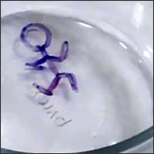

Materials:
- A glass plate, bowl, or picture frame
- Dry erase marker
- Water

Instructions:
- Draw a simple picture on the glass. A stick figure is a good one to start with
- Pour water onto the plate or into the bowl slowly to lift up the drawing
- Swirl the water around to make the picture dance and move

WATCH THE QUICK AND EASY VIDEO TUTORIAL!

https://www.youtube.com/watch?v=56diV8cdeDc&t=7s

How does it work?
The marker leaves behind mixture of pigments and a type of alcohol mixed together. The alcohol dissolves and the pigments are left behind as a solid. Glass is so smooth that the solid slides right off when it gets wet!

