Newton's Balloon Car

We build too many walls and not enough bridges!” So, let's build the first bridge for our child to learn the basics of science by demonstrating Newton's Law. The bridge will be to build your own balloon-powered car at home by using easy supplies and analyse the working of the same to grasp the fundamentals of science.
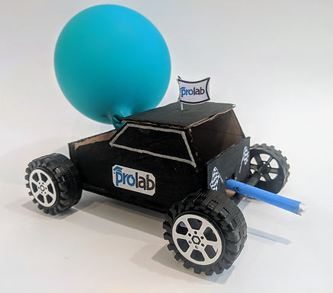
Introduction:
This activity will help students to learn about fundamentals of engineering design, kinetic energy - the energy that an object has due to its motion, potential energy - the stored energy that an object has because of its position or rather state along with having fun in racing them.
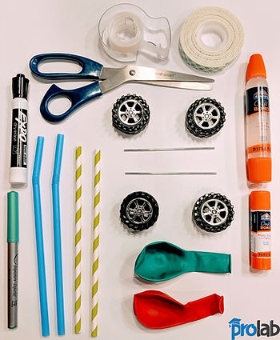

Requirements:
- Balloons
- Plastic straws
- Plastic straws & wooden skewers for axles
- Empty plastic bottles or cardboard containers
- Plastic bottle lids to make wheels of the car
- Transparent tape and Glue

Steps: (Time Required: 30 minutes)
- Cut the top of the bottle as per your requirement in order to have space where the balloon can rest. Leave the mouth of the bottle as it is.
- To make the car wheel axles cut the plastic straws in half. Attach these straws at the bottom of the bottle or container
- Tape each half of the straw crosswise on the bottom, one at the front side and the other at the back
- Insert the wooden skewers through the straws
- The axles should extend farther than the border edges of the car
- Create a hole at the centre of the bottle lids which will act as the car wheels. Attach the wheels on to the ends of skewers
- Make a hole at the backside of the bottle which is the backside of your car - the hole should be such that a straw can pass through
- Take a straw and attach a balloon to it
- Pass the straw attached balloon through the two holes that you created at the backside of the bottle and the one that you created right in the beginning
- Blow the balloon from the other end of the straw and the balloon-powered car is ready to be raced!!!

Learning Opportunity:
- This activity teaches us Newton’s Third Law of Motion: “For every action, there is an equal and opposite reaction”
- This explains that for every force which is being pushed on an object, there is an equal but opposite force pushing back
- Herein, the balloon pushes the air in one direction and the air pushes back on the balloon to make it go in the other direction
- The air is released from the balloon and the car is pushed in the forward direction

